Online Fee Payment Instructions

STEP 1: Login the school website and click on PARENT LOGIN.

STEP 2: Select CLICK HERE TO PORTAL LOGIN.
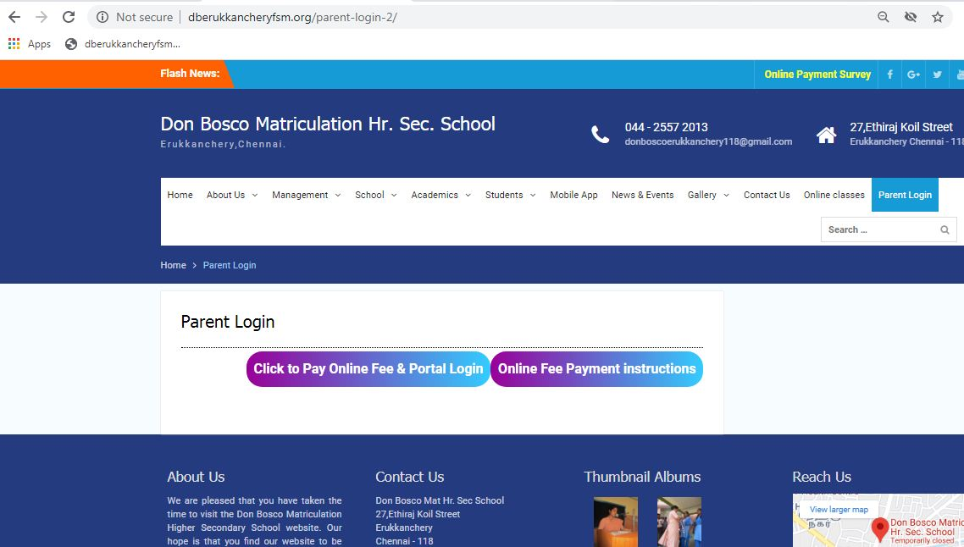

STEP 3: Login portal using credentials which was sent to your registered mobile number via SMS.

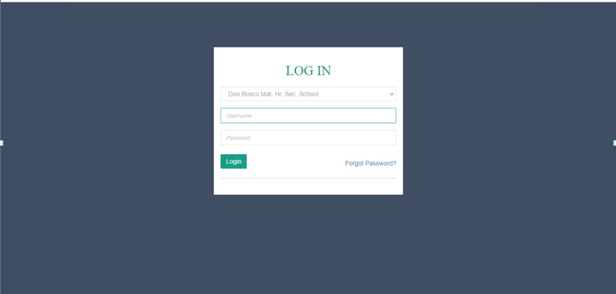

STEP 4: Click UPDATE MOBILE / EMAIL ID to update your details for transaction reference purpose.
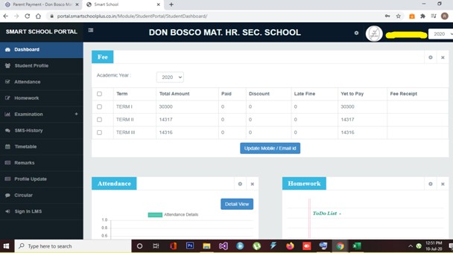

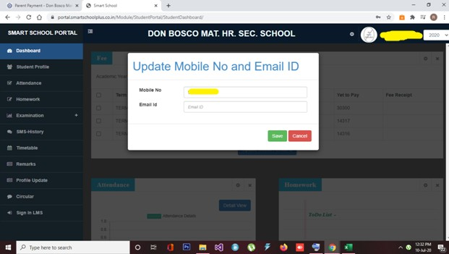

STEP 5: After updating mail id and phone number PAY NOW option will be enabled, select the particular term fee in the check box and click on to pay now.
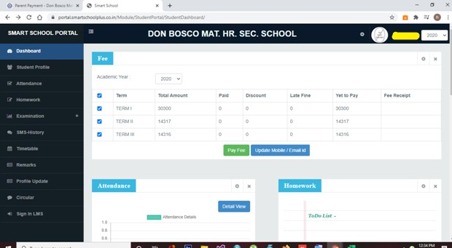

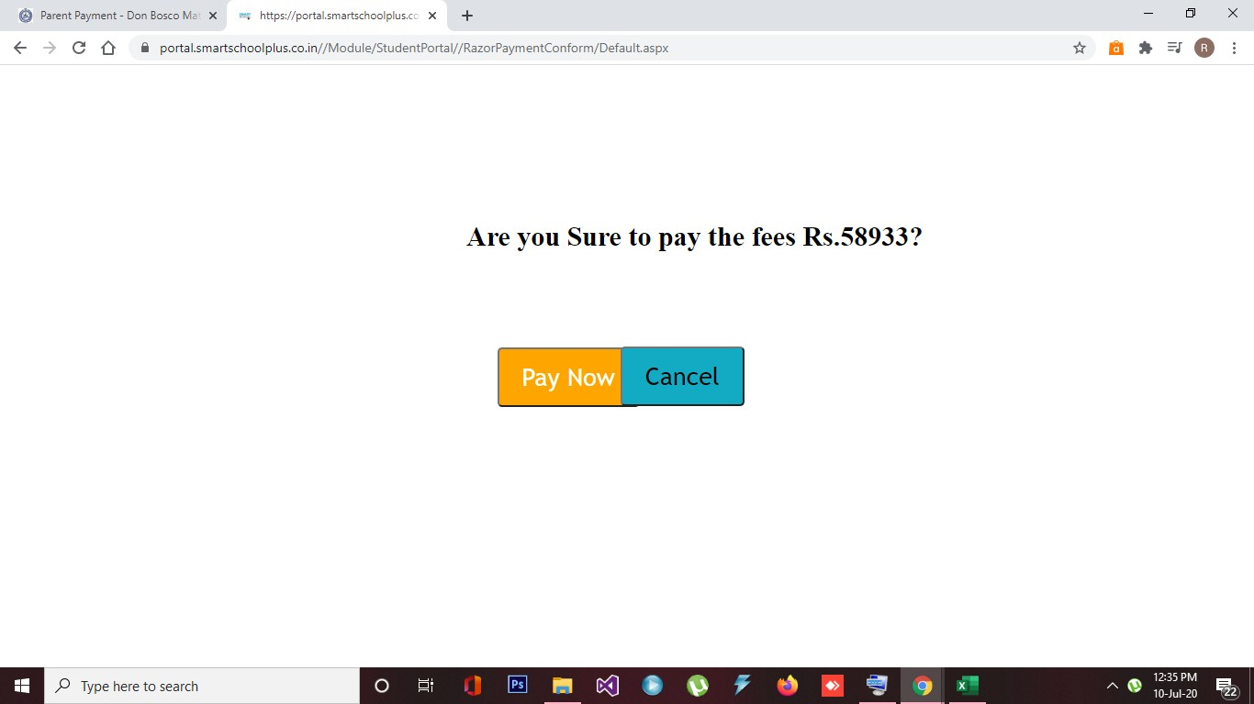

STEP 6: Kindly SELECT THE PREFERED PAYMENT GATEWAY to pay the fee.
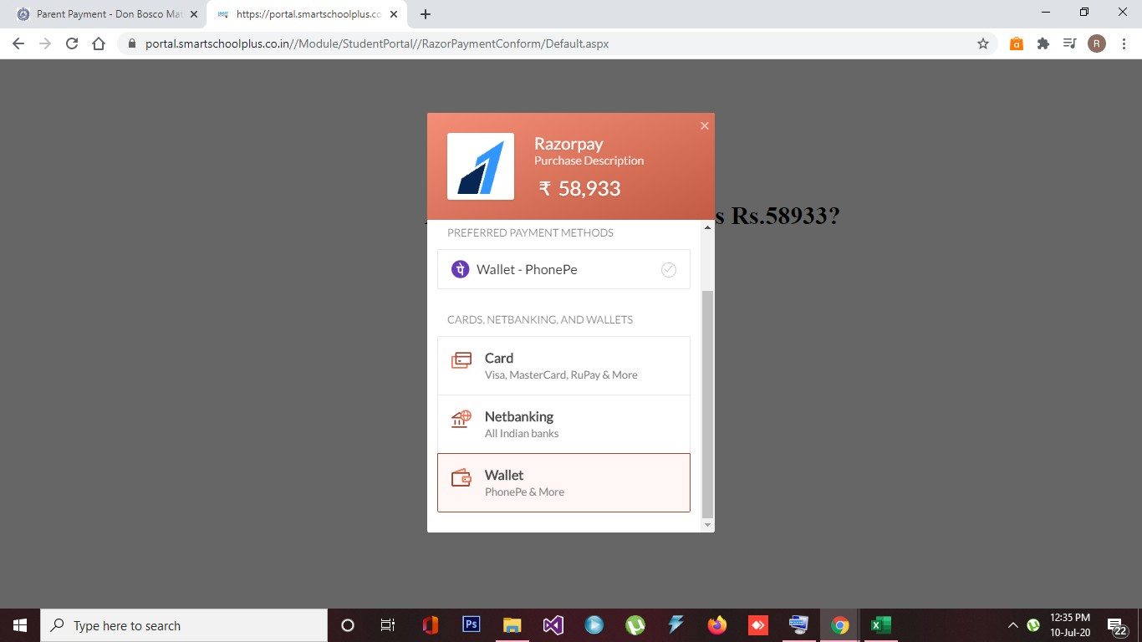

STEP 7: Once the payment is made successfully, you can download the fee receipt in the dashboard.
